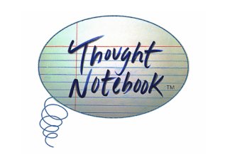

FOR IMMEDIATE RELEASE:

December 1st, 2014, Chicago, IL – Thought Notebook, the literary and visual arts journal based in Chicago, IL, will be releasing the final issue of their 2nd volume this winter.

Each issue of Thought Notebook has a specific focus; the December 2014 edition will delve into the minds of people from societies around the world and learn about how they view their circumstances. Artists from US cities like Chicago and New York, to Sweden and London ⎼ globally come together to bring the theme of the issue to life through a unique intersection of the written word and visual art.

Thought Notebook provides a global platform for literary and visual artists. The columns in each issue are an output of the thought patterns that arise from the issue’s theme, putting on display the observations of the issue’s study. Thought Notebook is based on a true story: humanity’s story.

Kat Lahr, Editor and Creative Director for Thought Collection Publishing says, “In trying to understand the nature of our occurrences in this issue, our research has found that we cannot deny patterns of interconnection in our lives even when we think that our life events are random. There tends to be design and order in human consciousness just as in the cosmos. ”

Each issue features an artist interview, and in this issue, artist Saramati Narasimhan reflects on a personal journey that led her to develop the Art For A Cause organization.

Thought Notebook is available digitally for $0.99 and in print for $16.99. 10% of each sale gets donated to social change organizations, each issue a different organization.

http://thoughtnotebook.org/journal-issues.html

Contact Information
Thought Collection Publishing
PO Box 35192
Elmwood Park, IL. 60707
kat@thoughtcollection.org
ISSN 2334-1572 and 2334-1599

